
Course:CBIO204: Fundamentals of Databases
Clinic Management System

Prepared by:

Jana Aref | 241001308
Mariam Ahmed | 241001648
Yomna Taha | 241001929
Nora Ahmed | 241002412
Kenzy walid | 242001189

Instructor:Dr Mohamed Mahmoud Elsayeh

GitHub repository link
https://github.com/tarqj4132-blip/Database-project

Clinic Management System

Project Overview
The Clinic Management System is designed to facilitate the process of scheduling appointments and storing patient medical information. The system consists of multiple departments, where each department contains several clinics and doctors. Patients can book appointments with doctors, and the system keeps track of appointment details, diagnosis, cost, and status.
The main objectives of the system are:
- Managing patient information.
- Managing doctor information.
- Managing clinic and department information.
- Scheduling appointments.
- Recording patient diagnoses.
- Tracking appointment costs and payments.
The system improves data organization, reduces paperwork, and provides efficient access to medical records and appointment schedules.

2. Conceptual Design

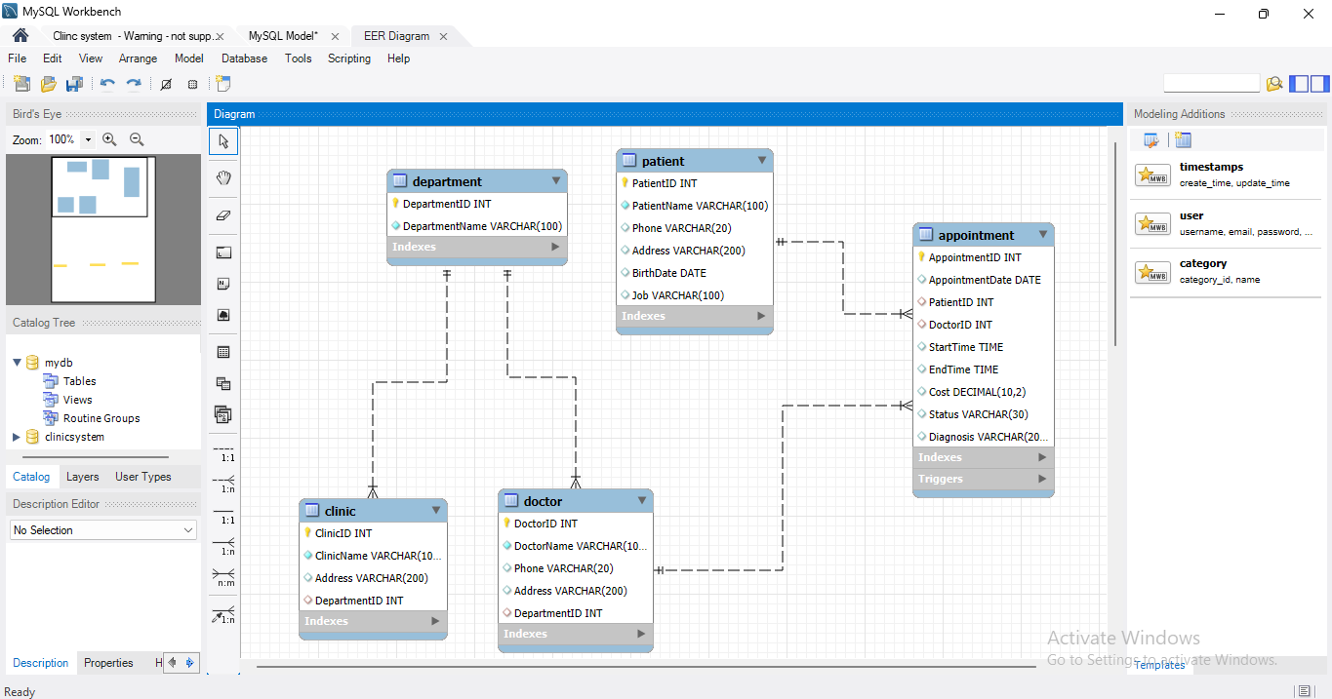

Department Entity
Attribute | Description
DepartmentID | Unique identifier for each department (PK)
DepartmentName | Name of the department

Clinic Entity
Attribute | Description
ClinicID | Unique identifier for each clinic (PK)
ClinicName | Name of the clinic
Address | Clinic address
DepartmentID | References Department (FK)

Doctor Entity
Attribute | Description
DoctorID | Unique identifier for each doctor (PK)
DoctorName | Doctor's full name
PhoneNumber | Doctor's phone number
Address | Doctor's address
DepartmentID | References Department (FK)

Patient Entity
Attribute | Description
PatientID | Unique identifier for each patient (PK)
PatientName | Patient's full name
PhoneNumber | Patient's phone number
Address | Patient's address
BirthDate | Patient's date of birth
Job | Patient's occupation

Appointment Entity
Attribute | Description
AppointmentID | Unique identifier for each appointment (PK)
AppointmentDate | Appointment date
StartTime | Appointment start time
EndTime | Appointment end time
Cost | Appointment cost
Status | Appointment status (Scheduled, In Progress, Postponed)
Diagnosis | Patient diagnosis
PatientID | References Patient (FK)
DoctorID | References Doctor (FK)

Cardinality Ratios and Participation Constraints
Relationship | Cardinality
Department → Clinic | 1 : N
Department → Doctor | 1 : N
Doctor → Appointment | 1 : N
Patient → Appointment | 1 : N

Participation Constraints

Relationship | Participation Type
Clinic in Department | Total
Doctor in Department | Total
Appointment with Doctor | Total
Appointment with Patient | Total
Department with Clinic | Partial
Department with Doctor | Partial
Patient with Appointment | Partial
Doctor with Appointment | Partial

.

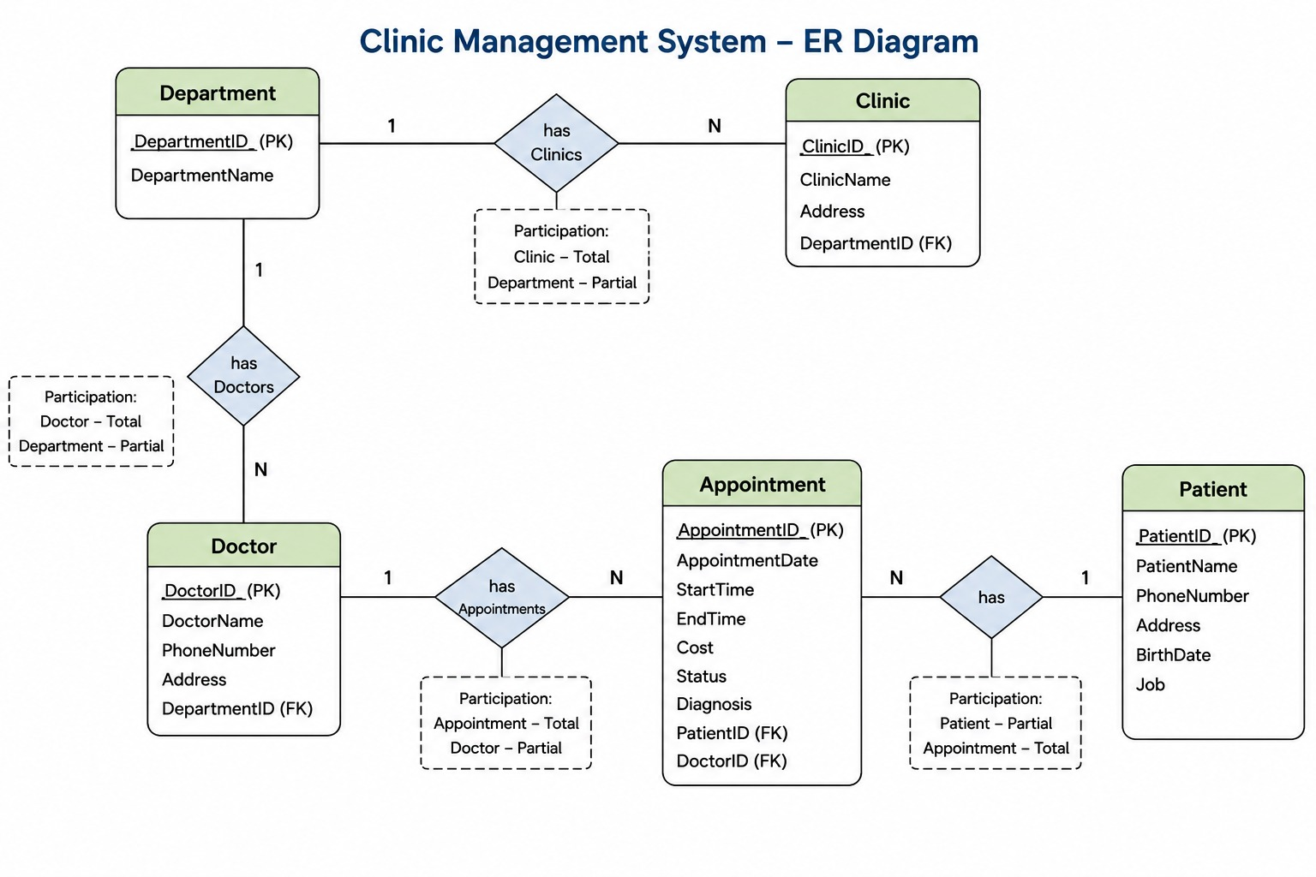

4. Relational Schema

Department Relation
Attribute | Constraint
DepartmentID | Primary Key (PK)
DepartmentName | NOT NULL

Clinic Relation
Attribute | Constraint
ClinicID | Primary Key (PK)
ClinicName | NOT NULL
Address | NOT NULL
DepartmentID | Foreign Key (FK) References Department(DepartmentID)

Doctor Relation
Attribute | Constraint
DoctorID | Primary Key (PK)
DoctorName | NOT NULL
PhoneNumber | NOT NULL
Address | NOT NULL
DepartmentID | Foreign Key (FK) References Department(DepartmentID)

Patient Relation
Attribute | Constraint
PatientID | Primary Key (PK)
PatientName | NOT NULL
PhoneNumber | NOT NULL
Address | NOT NULL
BirthDate | NOT NULL
Job | NULL Allowed

Appointment Relation
Attribute | Constraint
AppointmentID | Primary Key (PK)
AppointmentDate | NOT NULL
StartTime | NOT NULL
EndTime | NOT NULL
Cost | CHECK (Cost > 0)
Status | CHECK ('Scheduled', 'In Progress', 'Postponed')
Diagnosis | NULL Allowed
PatientID | Foreign Key (FK) References Patient(PatientID)
DoctorID | Foreign Key (FK) References Doctor(DoctorID)

Foreign Key Relationships
Parent Table | Child Table | Relationship
Department | Clinic | 1 : N
Department | Doctor | 1 : N
Doctor | Appointment | 1 : N
Patient | Appointment | 1 : N

5. Database Implementation
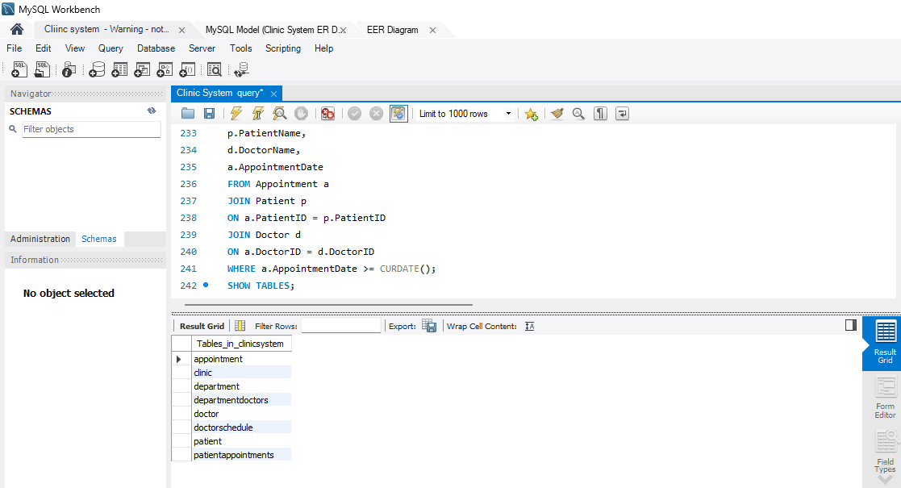

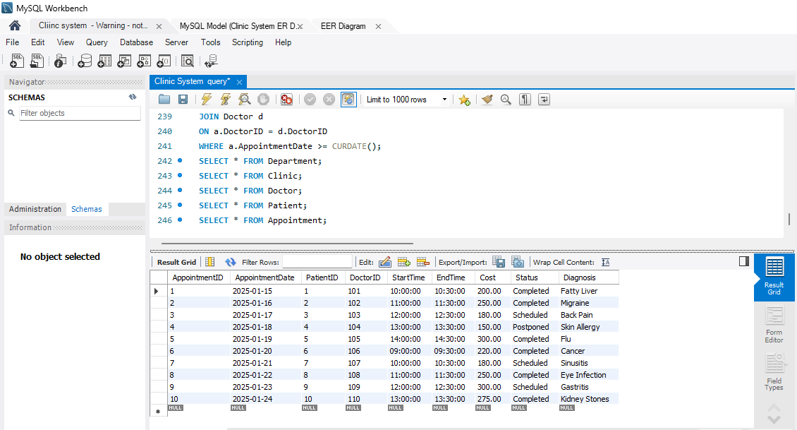

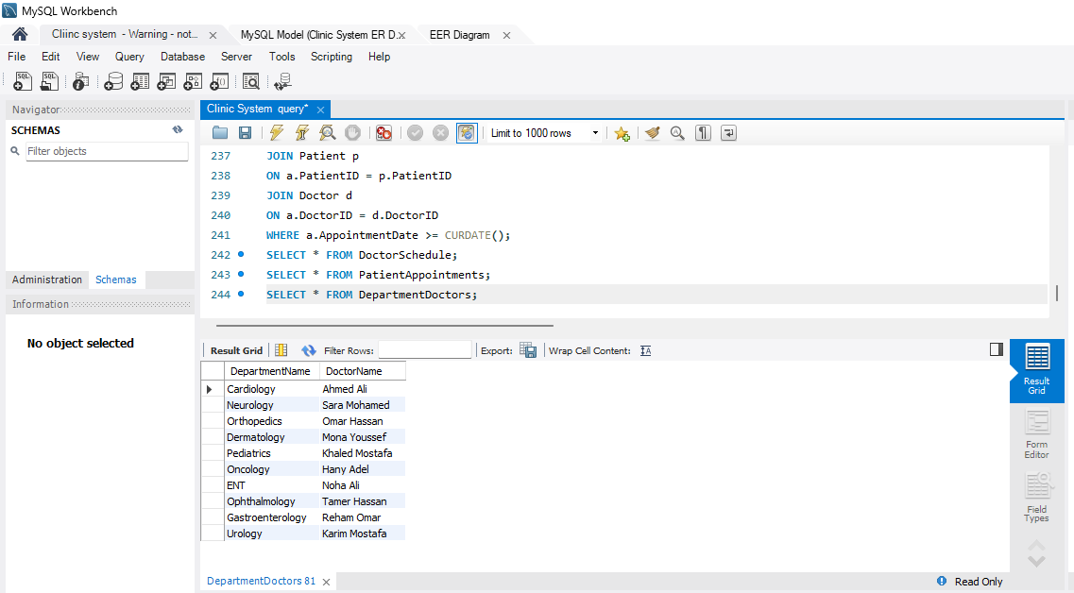
6. Views
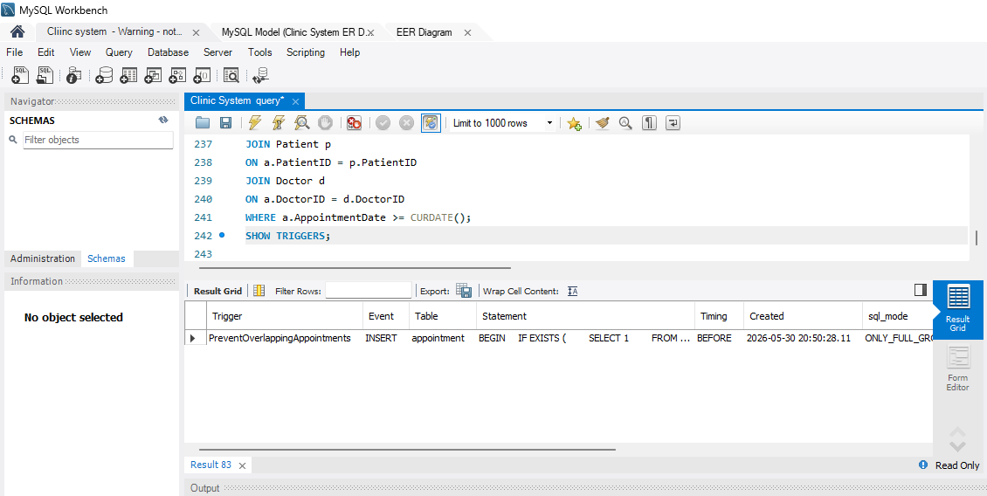
7. Trigger Implementation
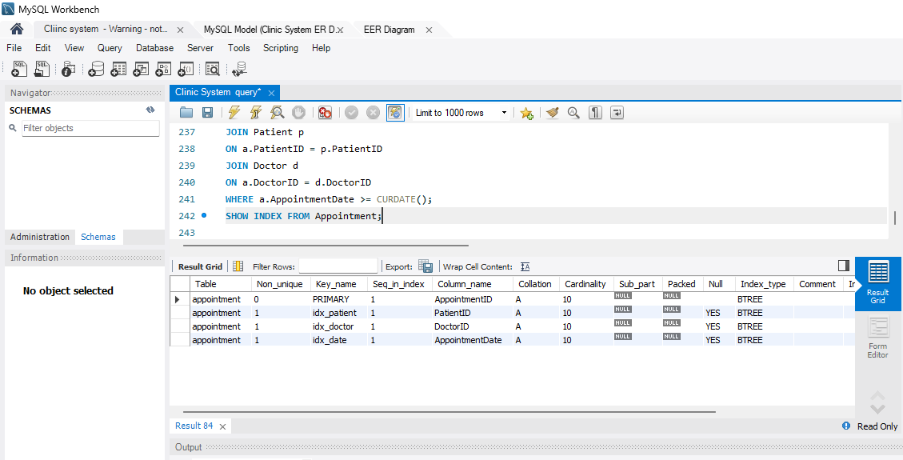
8. Indexes
9. Sample Queries and Results

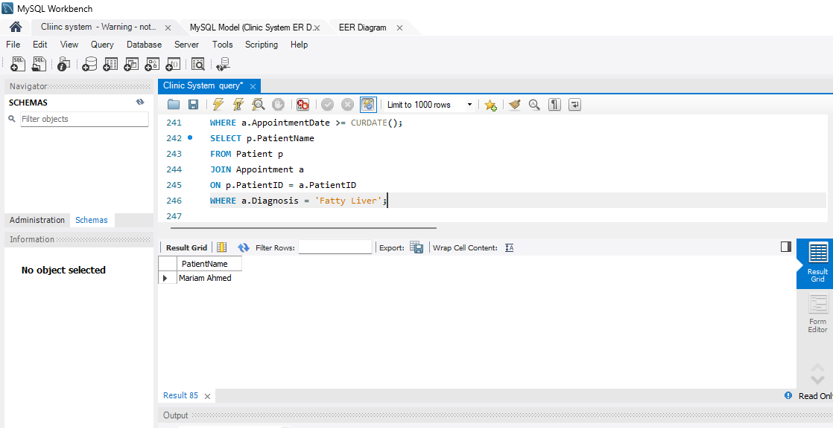
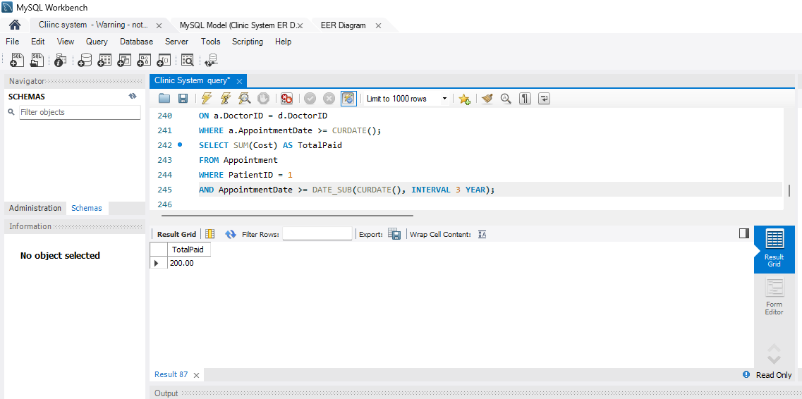
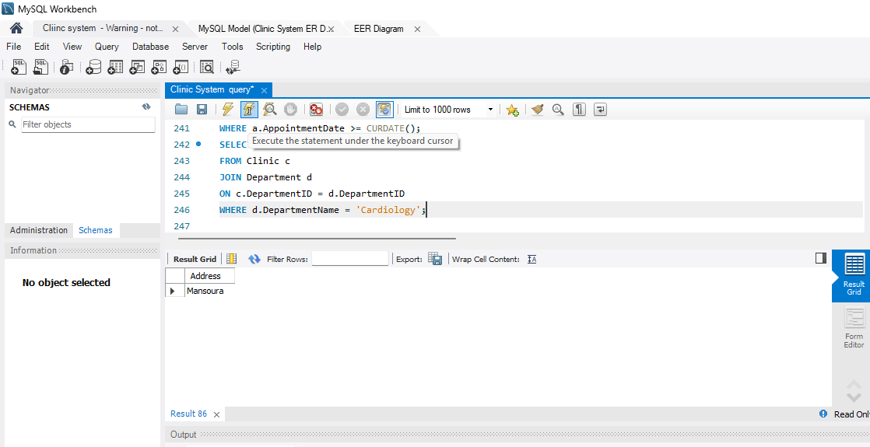
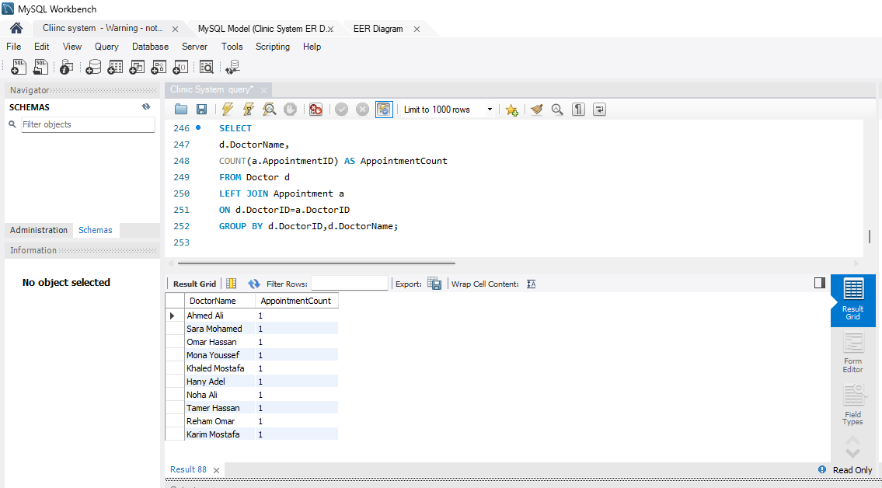

Conclusion
The Clinic Management System was successfully designed and implemented using MySQL. The database supports managing departments, clinics, doctors, patients, and appointments. Views, indexes, and triggers were used to improve performance and maintain data integrity.

